Earned runs
According to rule 9.16 of the OBR, an Earned Run (ER) is charged when, with less than three fielding chances, all advances on base by the player who reached home base can be attributed to the pitcher. An Earned Run is charged when advances are made for the following reasons:
- Batter-runner: safe hits, fielder’s choices (occupied balls), bases on balls (including intentional bases on balls), hit by pitch and, if it is not a fielding chance, advance to first base on K WP.
- Runners: all advances as a result of safe hits, stolen bases, sacrifice bunts, sacrifice flies, putouts, fielder’s choices, balks, wild pitches, catcher’s interference and forced advances due to the batter having been awarded first base.

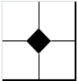 | In this respect it is worth noting that for an earned run, the small diamond in the center of each square, created with joined lines as the runner advances around the bases, should be filled in.
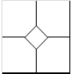 | If the run is not earned, the diamond is left blank.
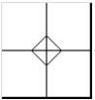 | If the run is NOT earned against the team, a cross must be drawn inside the diamond.

Before going into the complex matter of earned runs it is a good idea to look at what is meant by “fielding chance”.
A “fielding chance” is defined as any time when, in the scorer’s opinion, the defense has an opportunity to make a putout, regardless of whether the opportunity was taken successfully, or lost through error.
Fielding chances include: putouts, all decisive errors (including those that allowed the batter of a sacrifice hit to reach first base safely), all arrivals on base by batter-runners recorded with “K PB”, “OB” and, in specific cases, “K WP” (depending on the situation KL or KS in combination with PB or WP).
The reason the pitcher is not held accountable for runs scored after the third fielding chance is because, if the defense had capitalized on every such opportunity, they would have made three putouts and that phase of the inning would have ended.
In the example 1 given here, the defense has already had three fielding chances, as there have been two putouts, and a third runner reached base on an error.
WBSC |  | Traduction dans l’outil de scorage |  | Outil
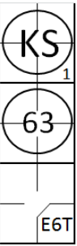 |  | /* Le premier batteur est strike out */  action { batter -> KS }  /* Le batteur suivant frappe une balle sur l'arrêt qui la relaie pour retirer le coureur batteur */  action { batter -> 63 }  /* Le batteur suivant atteint la première sur une erreur */  action { batter -> E6T } |  | 
A muffed foul fly should also be considered a fielding chance, as the batter could have been put out. There are also other situations in which there may be a fielding chance without the outcome being either a putout or a fielding error.
Usually, when there are two fielding chances on the same player, just one is counted, as any player can be put out only once. Example 2 shows two fielding chances by the error of the catcher and the fly ball caught by the right fielder.
WBSC |  | Traduction dans l’outil de scorage |  | Outil
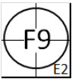 |  | /* Le batteur aurait du être retirer sur pop fly */  action { batter -> EF2 }  /* Le batteur est retiré sur un fly dans le champ droit */  action { batter -> F9 } |  | 
ATTENTION: These examples show situations in which there are two fielding chances on the same player, only one of which is counted.
Example 3: As the batter runner would have been put out if not for the error, there was no possibility for the pick-off.
WBSC |  | Traduction dans l’outil de scorage |  | Outil
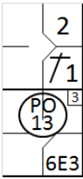 |  | /* Le premier batteur frappe une simple sur le lanceur */  action { batter -> 1B1 }  /* Le batteur suivant frappe une balle vers l'arrêt court qui le relai la balle vers le 1. Le défenseur comment une erreur */  action { batter -> 6E3 , runner1 -> + }  /* Le coureur en est retiré sur un 'pick off' */  action { runner1 -> PO13 } |  | 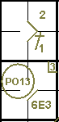

Example 4: There are two fielding chances on the runner put out on second base. It should be noted, however, that if this runner had been put out on first, rather than reaching base safely on an error, the defense would also have put out the next batter, thus making two putouts in all.
WBSC |  | Traduction dans l’outil de scorage |  | Outil
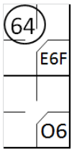 |  | /* Le batteur arrive sur base sur une erreur */  action { batter -> E6F }  /* Le batteur suivant frappe une balle sur l'arrêt court qui la relaie pour retirer le coureur */  action { batter -> O6 , runner1 -> 64 } |  | 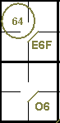
Consequently, in situations such as this, two fielding chances are counted. Any run scored by the runner who had reached base on an occupied ball would not be earned.
IMPORTANT: If, during the course of an inning, the defense has three fielding chances, no earned runs are charged to the pitcher. The reason for this rule is fairly easy to understand: if the three fielding chances had been translated into three putouts, the inning would have ended and the offensive team would not have been able to score any more runs. If, on the other hand, the inning continues, it is purely the defense’s responsibility that the fielding chances offered were not translated into putouts, which is why no further earned runs are charged to the pitcher.
A batter is automatically called out when, with less than two out and first base occupied, the third strike is a wild pitch. If first base is free, or if there are two out, the batter-runner may try to reach the base. If he succeeds, the symbol to use for his advance to first base is “KS1 WP” which is not usually a fielding chance but, as for all rules, there is an exception in this case.
Example 5: With no men out and first base occupied, the eighth man in the line-up hits a single to the right fielder, who fails to catch the ball. The batter-runner takes the opportunity to advance one base. The next batter swings at the third strike, which is also a wild pitch, and succeeds in reaching first base safely, while the other runners advance one base on the wild pitch.
WBSC |  | Traduction dans l’outil de scorage |  | Outil
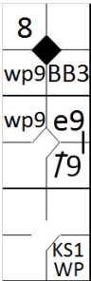 |  | /* Le premier batteur gagne la première base sur un 'base on ball' */  action { batter -> BB }  /* Le batteur suivant frappe un hit en champ droit et avance d'une base sur l'une erreur */  action { batter -> 1B9 e9 , runner1 -> ++ }  /* Le batteur suivant profite d'un troisième strike relâché, les coureurs avances */  action { batter -> KSWP , runner2 -> wp , runner3 -> wp earned } |  | 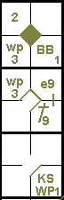

Example 6: If the right fielder in example 5 had not committed an error, the ninth batter would have found first base occupied and he would have been struck out, while the runners would have advanced one base on the wild pitch. “KS1 WP” in example 5 is therefore a fielding chance.
WBSC |  | Traduction dans l’outil de scorage |  | Outil
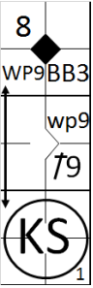 |  | /* Le premier batteur gagne la première base sur un 'base on ball' */  action { batter -> BB }  /* Le batteur suivant frappe un hit en champ droit et avance d'une base sur l'une erreur */  action { batter -> 1B9 , runner1 -> ++ }  /* Le batteur suivant profite d'un troisième strike relâché, les coureurs avances */  action { batter -> KS , runner1 -> wp , runner3 -> WP earned } |  | 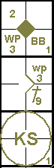

Example 7: A failed pickoff on first base allows the runner to advance to second and offers the batter the opportunity to reach first base on “KS1 WP”.
WBSC |  | Traduction dans l’outil de scorage |  | Outil
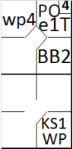 |  | /* Le premier batteur gagne la première base sur 'base on ball' */  action { batter -> BB }  /* Le coureur aurait du être retiré sue un pick off, mais avance sur une erreur */  action { runner1 -> POe1T }  /* Troisième strike relâché le batteur gagne la première base, le coureur avance sur la lancer fou */  action { batter -> KSWP , runner2 -> wp } |  | 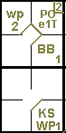

Example 8: If it had not been for the pitcher’s error, first base would have been occupied and therefore automatically off limits to the batter.
WBSC |  | Traduction dans l’outil de scorage |  | Outil
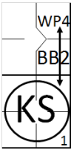 |  | /* Le premier batteur gagne la première base sur 'base on ball' */  action { batter -> BB }  /* Troisième strike relâché le batteur gagne la première base, le coureur avance sur la lancer fou */  action { batter -> KS , runner1 -> WP } |  | 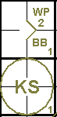
The “KS1 WP” is therefore a fielding chance.
Example 9: After having swung at the third strike, the batter-runner is able to advance to first base because of a previous passed ball. The “KS1 WP” is therefore a fielding chance.
WBSC |  | Traduction dans l’outil de scorage |  | Outil
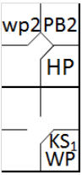 |  | /* Le premier batteur gagne la première base sur un 'hit by pitch' */  action { batter -> HP }  /* Le coureur avance sur une balle passée */  action { runner1 -> PB }  /* troisième strike relâché, le batteur gagne la première base, le coureur avance sur le lancer fou */  action { batter -> KSWP , runner2 -> wp } |  | 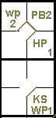

Example 10: Of the three runs batted in on the strength of the home run, only the first and last are earned, as the second batter reached first base on “KS1 WP” due to the previous passed ball. The “KS1 WP” is therefore a fielding chance.
WBSC |  | Traduction dans l’outil de scorage |  | Outil
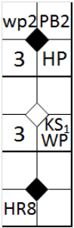 |  | /* Le premier batteur gagne la première base sur un 'hit by pitch' */  action { batter -> HP }  /* Le coureur avance sur une balle passée */  action { runner1 -> PB }  /* troisième strike relâché, le batteur gagne la première base, le coureur avance sur le lancer fou */  action { batter -> KSWP , runner2 -> wp }  /* Le batteur suivant frappe un home run, tout le monde marque un point */  action { batter -> HR8 earned , runner1 -> +++ , runner3 -> + earned } |  | 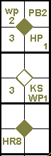
IMPORTANT: All advances as a result of a strikeout-wild pitch (KS1 WP) are considered legal as they occurred on a wild pitch.

